**Delivering personalized movie recommendations with an AI driven matchmaking system**

import pandas as pd

import numpy as np

from sklearn.model_selection import train_test_split

from sklearn.metrics import mean_squared_error

from sklearn.preprocessing import StandardScaler

from tensorflow.keras.models import Sequential

from tensorflow.keras.layers import Dense, Dropout

from tensorflow.keras.optimizers import Adam

from tensorflow.keras.callbacks import EarlyStopping

from tensorflow.keras.regularizers import l2

# Sample movie ratings data (expanded)

ratings = {

    "user1": {"movie1": 5, "movie2": 3, "movie3": 4, "movie4": 2, "movie5": 5},

    "user2": {"movie1": 4, "movie2": 5, "movie3": 3, "movie4": 5, "movie5": 1},

    "user3": {"movie1": 3, "movie2": 4, "movie3": 5, "movie4": 1, "movie5": 4},

    "user4": {"movie1": 2, "movie2": 3, "movie4": 4, "movie5": 5, "movie6": 3},

    "user5": {"movie2": 1, "movie3": 2, "movie4": 5, "movie5": 4, "movie6": 2},

    "user6": {"movie1": 5, "movie3": 5, "movie5": 3, "movie6": 4, "movie7": 5},

    "user7": {"movie1": 4, "movie2": 4, "movie4": 2, "movie6": 1, "movie7": 4},

    "user8": {"movie2": 2, "movie3": 3, "movie5": 5, "movie7": 2, "movie8": 5},

    "user9": {"movie1": 3, "movie4": 4, "movie6": 3, "movie8": 4, "movie9": 4},

    "user10": {"movie3": 1, "movie5": 2, "movie7": 5, "movie9": 3, "movie10": 5},

}

ratings_df = pd.DataFrame(ratings).fillna(0)  # Fill missing ratings with 0

# 1. Data Preprocessing

def preprocess_data(df):

    # Convert DataFrame to a user-movie matrix

    user_movie_matrix = df.T  # Transpose for user-centric rows

    # Split data into training and testing sets (80/20 split)

    train_data, test_data = train_test_split(user_movie_matrix, test_size=0.2, random_state=42)

    # Scale the data using StandardScaler

    scaler = StandardScaler()

    scaled_train_data = scaler.fit_transform(train_data)

    scaled_test_data = scaler.transform(test_data)

    return scaled_train_data, train_data, scaled_test_data, test_data, scaler #Return the scaler

# 2. Model Building

def build_model(input_dim):

    model = Sequential([

        Dense(128, activation='relu', input_shape=(input_dim,), kernel_regularizer=l2(0.001)),

        Dropout(0.5),

        Dense(64, activation='relu', kernel_regularizer=l2(0.001)),

        Dropout(0.3),

        Dense(32, activation='relu', kernel_regularizer=l2(0.001)),

        Dense(input_dim, activation='linear')  # Output layer with same dimension as input

    ])

    model.compile(optimizer=Adam(learning_rate=0.001), loss='mse')

    return model

# 3. Model Training

def train_model(model, train_data, epochs=50, batch_size=32, validation_data=None):

    early_stopping = EarlyStopping(monitor='val_loss', patience=10, restore_best_weights=True)

    history = model.fit(

        train_data,

        train_data,  # Autoencoder: input and target are the same

        epochs=epochs,

        batch_size=batch_size,

        validation_data=validation_data,

        callbacks=[early_stopping]

    )

    return history

# 4. Recommendation Generation

def get_user_recommendations(model, user_id, all_movie_names, user_movie_matrix, scaler, num_recommendations=5):

    if user_id not in user_movie_matrix.index:

        print(f"User '{user_id}' not found.")

        return []

    user_ratings = user_movie_matrix.loc[user_id].values.reshape(1, -1)

    # Scale the user's ratings using the same scaler

    scaled_user_ratings = scaler.transform(user_ratings)

    # Predict the user's ratings for all movies

    predicted_ratings = model.predict(scaled_user_ratings)

    # Inverse transform the scaled prediction to get actual ratings

    predicted_ratings = scaler.inverse_transform(predicted_ratings)

    # Create a DataFrame of movie names and predicted ratings

    movie_ratings_pred = pd.DataFrame({

        'Movie': all_movie_names,

        'Predicted_Rating': predicted_ratings[0]

    })

    # Get the movies the user has already rated

    rated_movies = user_movie_matrix.columns[user_movie_matrix.loc[user_id] > 0]

    # Filter out the movies the user has already rated

    recommendations = movie_ratings_pred[~movie_ratings_pred['Movie'].isin(rated_movies)]

    # Sort by predicted rating and get top N recommendations

    top_recommendations = recommendations.nlargest(num_recommendations, 'Predicted_Rating')

    return top_recommendations['Movie'].tolist()

def get_all_movie_names(df):

    movie_names = set()

    for user_ratings in df.values():

        movie_names.update(user_ratings.keys())

    return list(movie_names)

def main():

    # 1. Load and Preprocess Data

    all_movie_names = get_all_movie_names(ratings)

    scaled_train_data, train_data, scaled_test_data, test_data, scaler = preprocess_data(ratings_df)

    input_dim = scaled_train_data.shape[1] # Number of movies

    # 2. Build Model

    model = build_model(input_dim)

    # 3. Train Model

    print("Training the model...")

    train_history = train_model(model, scaled_train_data, epochs=100, batch_size=32, validation_data=(scaled_test_data, scaled_test_data))

    # 5. Generate Recommendations for a User

    user_id = "user1"

    num_recommendations = 5

    recommendations = get_user_recommendations(model, user_id, all_movie_names, ratings_df.T, scaler, num_recommendations) # Pass the scaler

    print(f"\nMovie recommendations for {user_id}: {recommendations}")

­

if __name__ == "__main__":

    main()

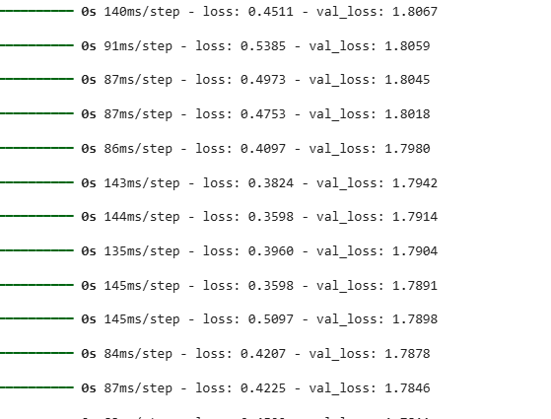**Output**